

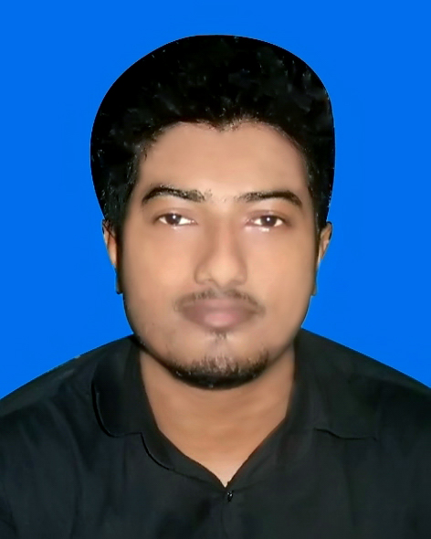

**MD. ARIFUL ISLAM**

7/C, South Begunbari,

Tejgaon I/A, Dhaka-1208.

Cell: +8801687496141

Mail: aktonmoy414@gmail.com

### Career Objectives:

To work with sincerity and integrity in a challenging atmosphere where my talent and knowledge will significantly contribute to the organizations target achievement and to become a successful personality with excellent career where hard work strict discipline and creative problem solving are the corner stone of success.

**PERSONAL INFORMATION:**

Name **:** Md. Ariful Islam

Father’s name **:**  Md. Masud Khan

Mother’s name **:**  Arzu Begum

Nationality **:** Bangladeshi (by birth)

Sex **:** Male

Marital Status **:** Unmarried

Date of Birth **:** 29November, 1997

Place of Birth **:** Dhaka

Religion **:** Islam (Sunni)

Blood Group **:** O+(ve)

National ID. No **:** 2407986732

**Education Qualification:**

|  |  |  |  |  |
| --- | --- | --- | --- | --- |
| **Name of Exam** | **Name of Institution** | **Year of Passing** | **CGPA/GPA** | **Board** |
| Diploma in Computer Engineering | Shariatpur Polytechnic Institute | 2017 | 3.24  (out of 4) | BTEB |
| S.S.C.  Science | BG Press High School | 2013 | 4.06  (out of 5) | Dhaka |

**Short Course:**

National Skill Standard Basic **(360Hrs)** 6 Months Course in **(''Auto Mechanics'')** at Dhaka Polytechnic Institute.

**COMPUTER & OTHER SKILLS:**

* Operating system: Windows –XP/7/8/10 Installation & Maintenance
* Application Software: Microsoft Office Program, Photoshop, Illustrator etc.
* Internet Browsing, E-mail, Printing, Computer Compose etc.
* Bangla & English Well Typing Speed.
* Computer’s Useful Software Knowledge.
* Data Entry
* Computer Troubleshoot, All Kinds of Computer & Laptop Assembly.
* Hardware & Software Management.

**JOB EXPERIENCE:**

1. Name of Company : Denso Automobile Engineering Ltd.

Designation : Mechanics

Duration : 2 Years

Address : Tejgaon I/A, Dhaka-1208

1. Name of Company : RPM Auto Solution.

Designation : Mechanics

Duration : 1 Year

Address : Tejgaon I/A, Dhaka-1208

1. Name of Company : Ranks Motor Workshop Ltd.

Designation : Mechanics

Duration : 2 Years

Address : Tejgaon Link Road, Dhaka-1208

1. Name of Company : Ranks Commercial Vehicle Ltd

(ASSEMBLY PLANT)

Designation : Production QC AND Maintenance All Equipment

Duration : 3 Years to till now

Address : Sonargaon, Naryayangonj

1. Name of Company : CLASSIC BD

Designation : Service Engineer AND Purchase Officer

Duration : 7 Month

Address : House#62 (4th Floor) . Road#14/1,Block-G,Niketon,Gulshan-1,Dhaka-1212

**LANGUAGE PROFICIENCY:**

English : Good command reading, writing and speaking.

Bengali : Excellent command over reading, writing and speaking.

Hindi : Good command listen & speaking.

**SELF COMMITMENT:**

* Ability to cope up with different situation.
* Very good temperament and enjoy challenges.
* Co-operative, Innovative & hardworking.
* Organizing & leadership competence.
* Possess the necessary dynamism to achieve results.
* Good communication skills and a very good team player.

**HOBBIES:**

* Reading ICT Related Books for Gather Knowledge.
* Reading Newspaper
* Sports (Football, Cricket, Chess)

**DECLARATION:**

I, the undersigned, certify that, to the best of my knowledge and belief this CV correctly describes my qualifications, my experience and me. I understand that any will full misstatement described herein may lead to my disqualification or dismissal, if employed.

DATE: MD. ARIFUL ISLAM 